Some time back all the IT infrastructure was on premises.   
There were in house servers managed by an IT/TIS team.  
  
Then with advent of cloud services these software and hardware services are now delivered over the internet rather than being on premises.  
  
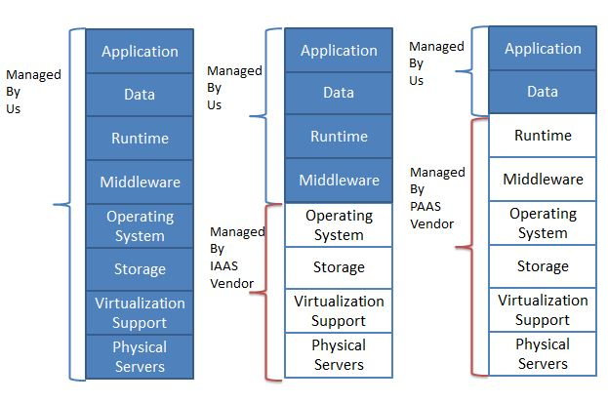

Let us now look at the advantages of PAAS over IAAS.

|  |  |  |
| --- | --- | --- |
|  | **IAAS** | **PAAS** |
| Example | Amazon Web Services(AWS) AWS | Pivotal Cloud Foundry(PCF) PCF |
| Deploying an application | We need to do the following steps   * Get a VM * Install Application Runtime * Deploy Application * Configure Load Balancer * Configure Service | we only need to push the application to the platform. In Pivotal Cloud Foundry this is done using cf push |
| Scalability | We need to do the following steps   * Get a VM * Install Application Runtime * Deploy Application * Configure Load Balancer * Configure Service | Scaling can be done very easily since it is the Platforms responsibility. In Pivotal Cloud Foundry this is done using cf scale |
| Vendor Lockin | Suppose we have deployed our application on AWS. Now due to some reason this needs to be moved to Azure. This will be very complex. | Our application runs on PAAS so migrating from cloud service provider to another is simple. For example Pivotal cloud foundry can be run on top of Azure or AWS. When we deploy the application on Pivotal, it provides us an abstraction over the cloud service providers |

**What is Cloud Foundry?**

Cloud Foundry is an open source, multi-cloud application platform as a service governed by the Cloud Foundry Foundation. The software was originally developed by VMware and then transferred to Pivotal Software, a joint venture by EMC, VMware and General Electric.  
  
It is a service (PaaS) on which developers can build, deploy, run and scale applications.  
  
Many Organizations provide the cloud foundry platform separately. For example following are some cloud foundry providers-

* Pivotal Cloud Foundry
* IBM Bluemix
* HPE Helion Stackato 4.0
* Atos Canopy
* CenturyLink App Fog
* Huawei FusionStage
* SAP Cloud Platform
* Swisscom Application Cloud

**Cloud Foundry Architecture**

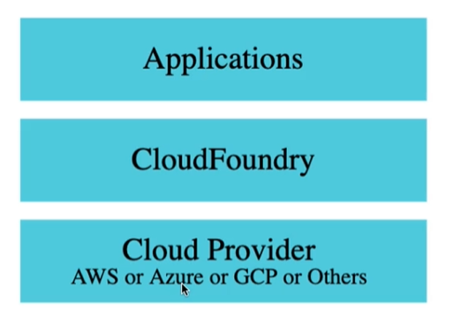

**PCF Architecture**     
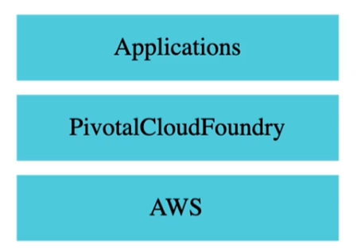

**Your Bible:**  
<https://docs.cloudfoundry.org/>